Database Basics

Chapter1 what is database.

Data: description of reality.

Information: conclusion from data.

The value of data: Accuracy, Consistency(time sensitive, data from when), speed(in time), Unify(organized in a way for easy and quick access), Share, Security, Ease(easy to use), Availability(easy, quick, accessible).

正確かつ整合性がとれていること

スピードが満たせること

一元的に管理されていること

多くの人の間で共有できること

不正に使われないように守られていること

簡単に取り扱え、加工ができること

必要なときにいつでも取り出せること

Chapter2 what is the difference between file sys and database.

File sys: just data storage. File can not be shared by different program.

DBMS(database management system): Data are stored in a particular place, and can be shared by different programs.

Difference:

|  |  |
| --- | --- |
| File sys | DBMS |
| Loction of data has to be pointed in program | No need to describe location |
| When operated by multi programs, program has to control the operation to avoid miss | No need to care about multi program operation. |

Chapter3 types of database

Hierarchical DB model: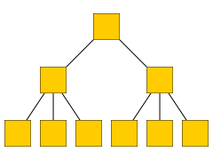 Like a parent tree. One way only. Easy to have redundancy. Programmers have to understand the contracture.

Network DB model: 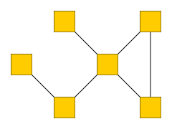 Like a net, multi-multi. Excluded redundancy. Still need programmers to understand the contracture.

Relational model: 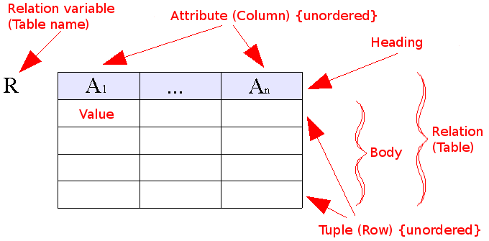 2 dimensions. Row=item, column=record. Multi sheets to describe relationship. Data access tool: SQL, data access way: describe purpose.

Merits of relational model: program and data are seperated. Flexible. Easy operation.

Chapter4 Introduction of Relational DB

Key elements of Relational DB: table, database_engine, SQL.

Table: row-record, field-column. Locate data with row and column.

DB engine: clients(program) <-> DB engine <-> DB. Clients pass request to DB engine, DB engine take the data and feedback. DBMS is consisted by process and memory.

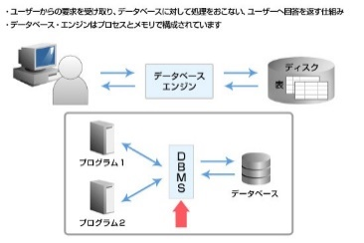

SQL(Structured Query Language): standard language used by DB.

SQL types: 1. Data definition, DDL; 2. Data manipulate, DML: search, update, insert, delete, combine tables. 3. Transaction management, DCL.

SQL commend examples:

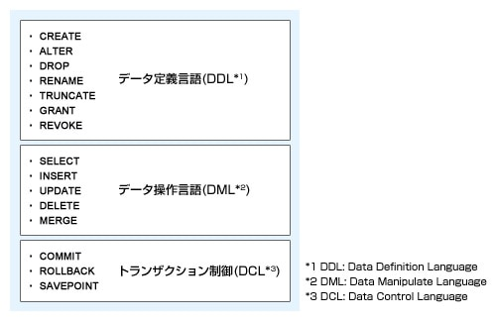

Data utilization of Relational DB:

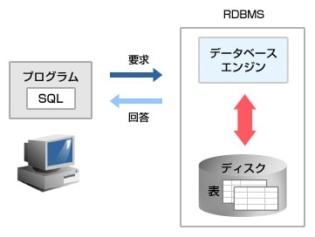

Chapter 5 SQL

SQL grammar:

1. Data definition, DDL; 2. Data manipulate, DML: search, update, insert, delete, combine tables. 3. Transaction management, DCL.

Not process oriented.

Example:

DDL: CREATE TABLE [表名] （

）；

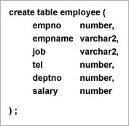

DML:

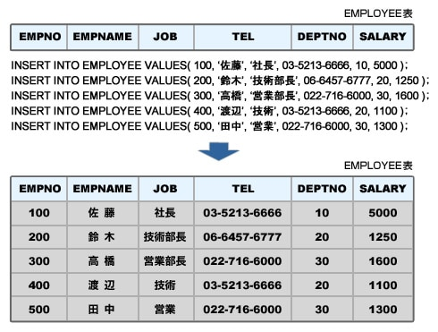

DML: SELECT カラム名 FROM 表名 WHERE データを取り出す条件；「*」を使ってすべてのカラムを指定します。

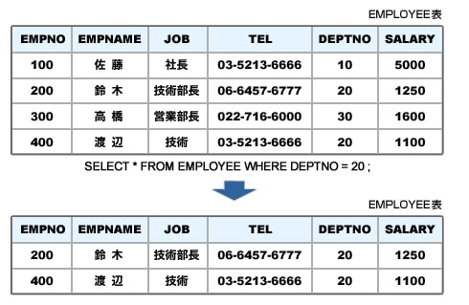

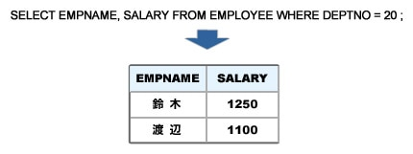

DML: UPDATEテーブル名SET列名=データの値,列名=データの値,・・・WHERE条件；

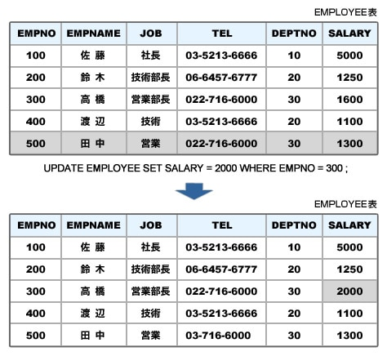

DML: DELETE FROM 表名 WHERE 条件；

例）EMPLOYEE表から社員番号:300番のデータを削除する。

DELETE FROM 従業員 WHERE 社員番号=300;

Chapter 6 Other DB function: Transaction, lock, security

Transaction:

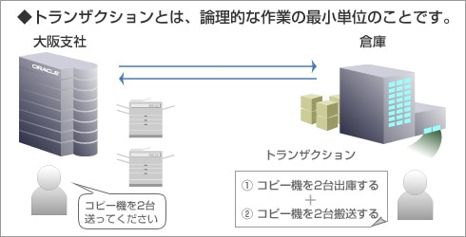

Transaction finish: Commit (DCL)

Transaction cancellation: Rollback (DCL)

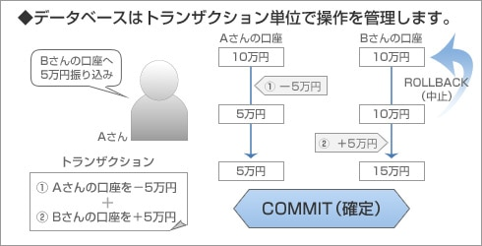

Lock: avoid overwrite during multi-operation.

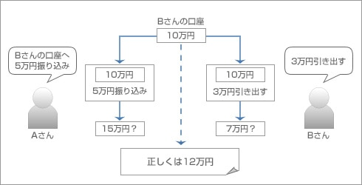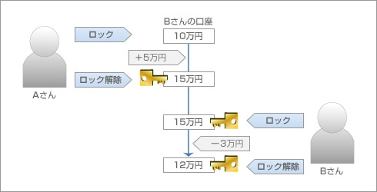

Security: Authentication, Access control(Authority), Audit, Encryption.

1.who is accessing? 2. Has authority? 3. What has been done? 4. Net security.